Butrus al-Bustani بطرس البستاني (1819-1883)

Mark D. Luce (AFFILIATION)

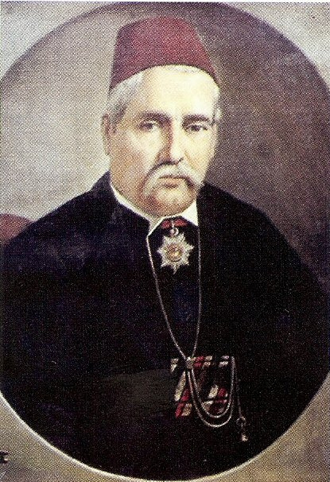

**Summary**

Butrus al-Bustani is called the ‘Father of the Arabic Renaissance’ and was a leading pioneer of the al-Nahda ( النهضه )or cultural awakening. Al-Bustani sought to promote Arabic as a national language, long-neglected by the Ottoman Turks, and to make it a suitable vehicle for communicating implementing educational reform and imparting new scientific and technical knowledge from Europe and the West. He helped to found the Syrian Scientific Society ( الجعمية العلمية السورية al-Ja'miyya al-'ilmiyya al-suriyya)

Al-Bustani participated in the American Protestant Mission's Bible translation project. In 1870, he completed his large Arabic dictionary *The Ocean of Oceans* ( محيط المحيط Muhit al-Muhit) and the first volume of his encyclopedia, the *Dictionary of Knowledge* (دائرة المعارف Dairat al-ma'arif) appeared in 1876. He died while engaged with this massive project. He was able to produce only six volumes. His son Salim carried on his father's work and completed another two volumes. This encyclopedia was never completed but eleven volumes were published.

**Butrus Bustani (1819- 1883)**

Butrus al- Bustani, the ‘ Father of the Arabic Renaissance’ and a titan of the ‘Arab Awakening’ (*al-Nahda النهضة* ) was born into a Christian Maronite family in Lebanon. He became a teacher, learned English, and while in Beirut met American Protestant missionaries. He converted to Presbyterianism and worked with the American mission. He assisted the scholar and missionary Cornelius Van Allen Van Dyck with the *Bible*translation project that occupied him for ten years.

**Al-Bustani's Major Contributions to the Arabic Language**

After completing this project, he began compiling a dictionary of the Arabic language, *The Ocean of Oceans* ( محيط المحيط Muhit al-Muhit) . It was completed in 1870 and published in two volumes. However, al-Bustani condensed it into the *The Drop of the Ocean* ( قطر المحيط Qutr al-Muhit), so that it would be more available to students.

Al-Bustani's second great work was an Arabic encyclopedia the *Dictionary of Knowledge*(دائرة المعارف *Dairat al-ma'arif*), which utilized European sources as well as information drawn form Arabic literary and historical sources. It appeared in six volumes in 1883. The first volume appeared in 1876. After his death, is son Salim completed two more volumes. It was never finished but eleven volumes were published.

**Al-Bustani's Major Contributions to the Awakening (Nahda)**

In the aftermath of the Maronite-Druze civil war of Mount Lebanon in 1860 in which Christians, Druse, and Muslims massacred each other, al-Bustani founded a weekly newspaper called *Nafir Suriya* (1860/1 *The Syrian Trumpet*). It was the first political journal ever published in the country and advocated for religious tolerance and union in the pursuit of knowledge.

Additionally, al-Bustani founded ‘The National School’ (al-Madrasa al-Wataniya , hoping that it would help to heal regional religious strife. It created an environment that he envisioned for society. The school provided boys of all religions, ethnicities, and cultural backgrounds with an education, teaching religious tolerance and patriotic ideals. Bustani wrote most of the textbooks employed at the school. The school continued to operate until 1877.

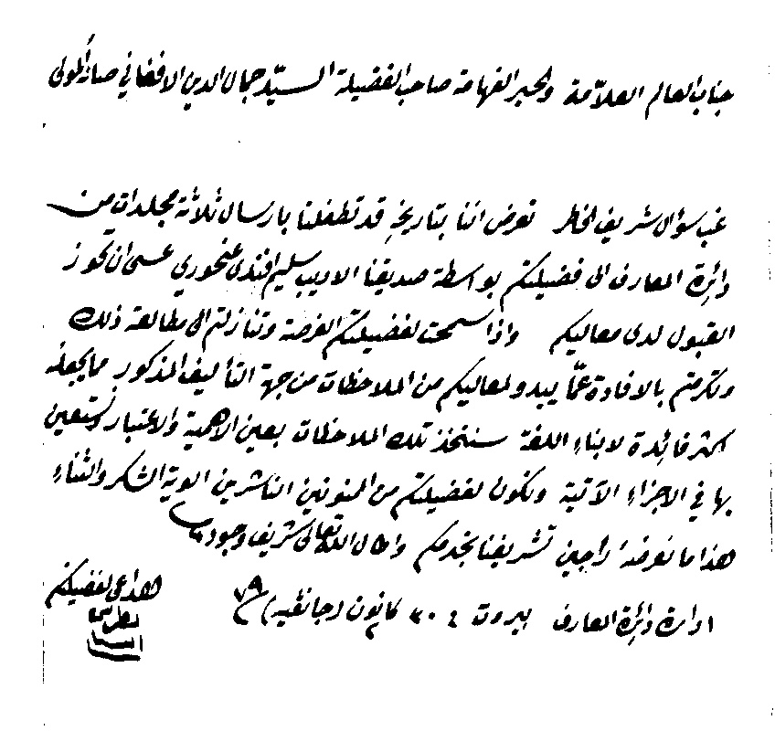

A copy of a letter from al-Bustani to Jamal al-Din al-Afghani. Al-Bustani sent al-Afghani copies of his encyclopedia.

<https://www.h-net.org/~bahai/areprint/afghani/bustani.htm> (accessed, 07/13/2015)

During this period there was a proliferation of literary and scientific journals. Al-Bustani believed that journals were an effective method of educating the masses. In 1870, he founded the journal *al-Jinan* ) الجنان 1870 - 1886, *The Garden*) and with his son Salim, the journal, *al-Janna* ( الحنة *Paradise*). A year later al-*Junayna* ( الجنينة *Little Garden*) was established.

*Al-Jinan* was a bi-weekly publication devoted to politics, current events, history, culture, education, and social reform, introducing the concept of modernity. Its slogan or motto was ‘the love of homeland is of faith’ ( حب الوطن من الايمان hubb al-watan min al-iman). It became a prototype for many Arabic journals for endeavoring to integrate the Arab world in a new emerging modern age.

Al-Bustani believed that sectarian strife and conflict were caused by ignorance. He devoted his entire life to education, social reform and the promotion of understanding and national unity. His influence was enormous and he truly deserves the title, ‘Father of the Arabic Renaissance.’

Al-Bustani’s works on education

‘Discourse on Education Given at the National School.’ In: Al-Jinan (Beirut), no. 3, 1870.

‘The National School.’ In: Al-Jinan (Beirut), no. 18, 1873.

‘Discourse on Science among the Arabs’, Beirut, 15 February 1859.

‘Discourse on the Education of Women’, given in 1849 at the meeting of members of the Syrian Association and published in the Actes de l’Association syrienne, Beirut, 1852.

‘Discourse on Social Life’, Beirut, 1869.

Boutros al-Boustani. Textes choisis. With a commentary by Fouad Ephrem al-Boustani. Beirut, Publications de l’Institut des Lettres Orientales, 1950. (Collection Al Rawai’)

The writings and speeches of Boutros el-Boustani, either in published or manuscript form, are preserved in the ‘Yafeth’ Library at the American University of Beirut.

Further Readings

Makdisi, Ussama. ‘After 1860 : Debating Religion, Reform, and Nationalism in the Ottoman Empire’ *International Journal of Middle East Studies.* **34** (2002), 601–617.

[Sheehi](https://en.wikipedia.org/wiki/Stephen_Sheehi), Stephen. [*Foundations of Modern Arab Identity*](https://en.wikipedia.org/wiki/Foundations_of_Modern_Arab_Identity), [University Press of Florida](https://en.wikipedia.org/wiki/University_Press_of_Florida), 2004.

Mahmoud Awadallah. Arab Nationalism. <https://www.youtube.com/watch?v=d2VYaHCVYG8> (10:10 minutes)

**List of Works, References and Periodicals of Butrus al-Bustani**

**Kashf al-Hijab fi ‘Ilm al-Hisab**. Beirut, 1848.

**Rawdat al-Tajir fi Mask al-Dafatir.** Beirut, 1851

**Khutba fi Adab al-‘Arab.** N.p., n.n., n.d. A condensed version extemporaneously given speech in Beirut on February 15, 1859.

**Qissat As’ad al-Shidyaq.** Beirut, 1860.

**Nafir Suriya.** Beirut, 1860- 61.

**Miftah al-Misbah fi al-Sarf wa al-Nahw.** Beirut, 1862.

**Muhit al-Muhit.** 2 vols. Beirut, 1867-70.

**Qutr al-Muhit.** 2 vols. Beirut, 1869.

**Khitab fi al-Hay’a al-Ijtima’iya wa al-Muqabala bayna al-‘Awa’id al-‘Arabiya wa al-Ifranjiya.** Beirut, Matba’at al-Ma’arif, 1869.

**Al-Jinan.** Beirut, 1870-84. Edited by Butrus and Salim al-Bustani. This journal was combined with **al-Janna** continued until 1886 by Najib al-Bustani.

**Al-Janna.** Beirut, 1870-84. Edited by Butrus and Salim al-Bustani. This journal was combined with **al-Jinan** continued until 1886 by Najib al-Bustani.

**Al-Junayna.** Beirut, 1871-75. Edited by Butrus, Salim and Sulayman al-Bustani.

**Da’irat al-Ma’arif.** 11 vols. Beirut, 1876-1900. Six volumes completed by Butrus. The remaining volumes were completed by members of his family.

Works Translated, Edited or Adapted by al-Bustani

Smith, Eli. **Al-Bab al-Maftuh fi A’mal al-Ruh.** Translated from the English (**A Treatise on the human Soul.**) by Butrus al-Bustani. Beirut, 1843.

Bunyan, John. **Kitab Siyahat al-Masihi.** Translated from the English (**The Pilgrim’s Progress**, Pt.1) by Butrus al-Bustani. Beirut, 1844.

al-Bustani, Butrus (ed.) **A’mal al-Jam’iya al-Suriya.** Beirut, American Mission Press, 1852. Includes al-Bustani’s ‘Khitab fi Ta’lim al-nisa’,’ ‘Fi Madinat Bayrut,’ and ‘al-Hariri.’

Farahat, Jarmanus. **Misbah al-Talib fi Bahth al-Matalib, Mutawwal fi al-Sarf wa al-Nahw wa ‘Ilm al-‘Arud wa al-Qawafi.** Edited version of **Bahth al-Matalib** with commentary by Butrus al-Bustani. Beirut, 1854.

Al-Shidyaq, Tannus ibn Yusuf. **Akhbar al-A’yan fi Jabal Lubnan.** Edited by Butrus al-Bustani. Beirut, 1859.

Al-Mutanabbi, Abu alTayyib Ahmad ibn al-Husayn. **Diwan al-Mutanabbi.** Edited with notes by Butrus al-Bustani. Beirut, 1860.

Defoe, Daniel. **Al-Tuhfa al-bustaniya fi al-Asfar al-Kruziya aw Rihlat rubinsun Kruzi.** Translated from the English (**Adventures of Robinson Crusoe**) by Butrus al-Bustani. Beirut, 1861.

**Al-Kitab al-Muqaddas.** The **Bible** translated into Arabic. New York: American Bible Society, 1867. Translation started by Eli Smith, butrus al-Bustani and Nasif al-Yaziji, completed by Cornelius Van dyck and yusuf al-Asir.

Edwards, Jonathan. **Kitab Ta’rikh al-Fida’.** Translated from the English (**History of Redemption**). Beirut: American Mission Press, 1868.

Merle-D’Aubigne, Jean Henri. **Ta’rikh al-Islah fi al-Qarn al-Sadis ‘Ashr.** Translated from the English (**History of the Reformation in the sixteenth Century**). Beirut: American Mission Press, 1878.